
Information Architecture
Project XXXX
Client YYYY
<<Note: This document provides a generic template. It may require tailoring to suit a specific client and project situation.>>
Table of Contents
1 Data Principles 3
2 Target Conceptual Data Model 4
3 Data Entity/Business Function Matrix 6
4 List of Stakeholders and Concerns 7
5 Current and Target Information Architecture 8
6 Data Gaps and Recommendation 9

Document Information
Project Name: | Project XXX
Prepared By: |  | Document Version No: | 0.1
Title: | Information Architecture | Document Version Date:
Reviewed By: |  | Review Date:
Distribution List
From | Date | Phone/Fax/Email

To | Action* | Due Date | Phone/Fax/Email
* Action Types: Approve, Review, Inform, File, Action Required, Attend Meeting, Other (please specify)
Document Version History
Version  Number | Version  Date | Revised By | Description | Filename

Data Principles
Name | Data Integration
Statement | Data is defined consistently throughout the company, and the definitions are understandable and available to all users
Rationale | With integration between applications, it will allow quicker business turnaround times.
Implications | Multiple data standardization initiatives need to be co-ordinated.

Name | Data Replication
Statement | Data to be replicate and assessable without interrupting online transaction
Rationale | For efficiency and effectiveness in decision-making and service delivery.
Implications | Data is should be sufficiently, able to meet a wide range of requirement.

Name | Data is an Asset
Statement | Data is an asset that has value to the company and is managed accordingly
Rationale | The purpose of data is to aid decision-making.
Implications | Stewards must have the authority and means to manage the data for which they are accountable

Target Conceptual Data Model

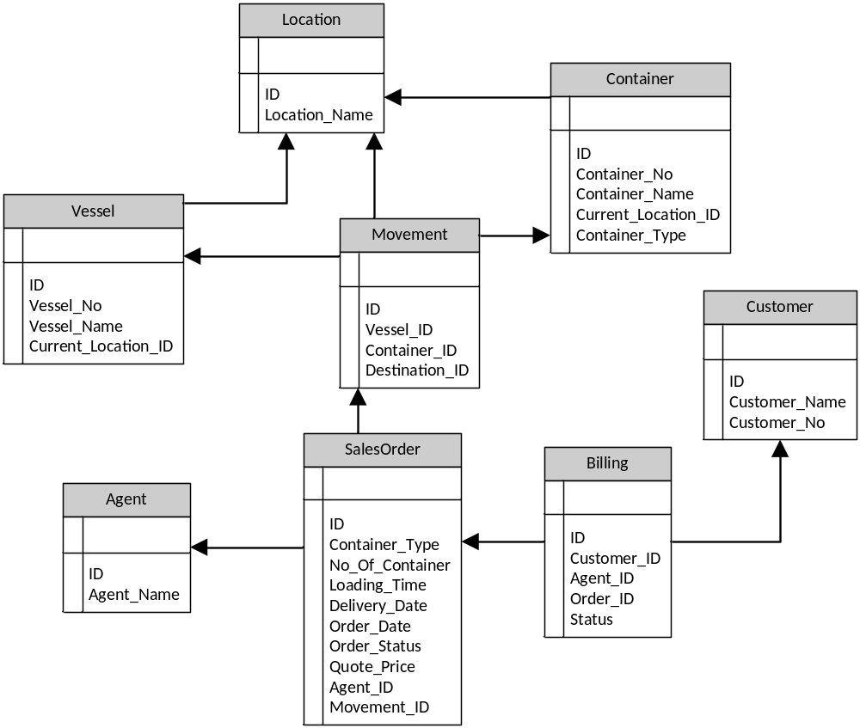

Data Entity/Business Function Matrix

Data Entities  Business Function | Sales Order | Vessel | Container | Billing
Request for Quotation | CRUD | CRUD | CRUD | C
Availability of Vessel | R | R
Availability of Container | R |  | R
Check Vessel schedule | R | R | R
Container Movement Order |  |  | CRU
Calculate price | RU
Update quotation | RU |  |  | RU
Sales Summary | R | R | R | R

Application/Data Matrix

Data  Application | Sales Order | Vessel | Container | Billing
Vessel Management System | R | CRUD | R
Container Management System | R | R | CRUD
Sales Order System | CRUD | R | R | RU
Billing System | R |  |  | CRUD

List of Stakeholders and Concerns

No | Concerns | View | Stakeholders
1 | Customer RFQ/Order manually processed through email, fax and phone | Conceptual data model, Data entity/ Business Function Matrix | Sales Team
2 | Sales Order and Customer Billing System integration | Conceptual data model | Sales Team, Order Processing Administrator
3 | Inaccurate sales report and transaction data due to human activities | Data entity/Business Function Matrix | CxO

Current and Target Information Architecture

Current:
Each individual system had their own data/information
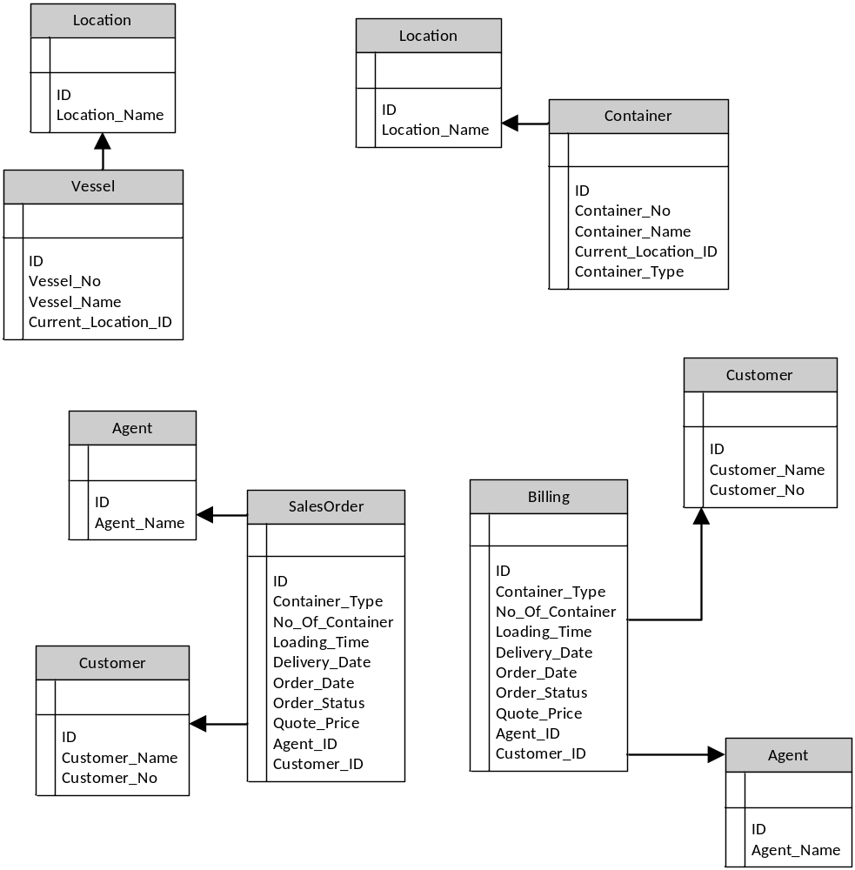

Target:

Data Gaps and Recommendation

No | Data Gaps | Recommendation
1 | Different data format between Company with Port Operators | Work together to follow or create a standard that be used by both parties
2 | Duplicate Customer, Agent entity in Sales Order and Billing System | To be merged
3 | Duplicate Location entity in Vessel and Container Maintenance System | To be merged

Target  Baseline | Vessel | Container | Movement | SalesOrder | Agent | Customer | Billing
Vessel | Included
VesselLocation
Container |  | Included
ContainerLocation
SalesOrder |  |  |  | Included
SalesOrderAgent |  |  |  |  | Potential match
SalesOrderCustomer |  |  |  |  |  | Potential match
Billing |  |  |  |  |  |  | Included
BillingAgent |  |  |  |  | Potential match
BillingCustomer |  |  |  |  |  | Potential match
NEW |  |  | Gap: To be developed or produced

